**Finalize Change Request Approach with Project Manager**

**Module Description**

During this module, you will meet with the Project Manager to discuss the plan and approach to address each Change Request. The Project Manager will provide insights and recommendations for changes, if required.

**Participant Presentation**

Click the link to launch the [Module 44 Presentation](https://accenture.desire2learn.com/content/enforced/9406-Pending/W4_Participant_Materials/Module_44/ADF_2_0_Java_M44_TimeWarp_PD.pptx?_&d2lSessionVal=YnoL4daZGC8ne2RyGf0cWMrk8).

**Scenario**

You will meet with the Project Manager to:

1. Quickly summarize the Change Requests for discussion.  
2. Summarize the steps taken to review the Change Request's impact.  
3. Present the results of the impact analysis (what items are affected).  
4. Describe the proposed solution.  
5. Share initial estimates on the enhancement.  
6. Explain what will happen if the enhancement is not done.  
7. Provide your recommendation.

After the meeting, the Project Manager will go to meet with the Change Advisory Board to determine what the next step will be for each Change Request (and the cost/impact of each choice):

1. Defer - move it to Release 3 for another team to work on.  
2. Fix - your team will work on fixing within the decided time schedule.  
3. Reject - the client doesn't wish to pay for the fix (cost outweighs the benefit at this time).

**ADM Activity Context Diagram**

**High Level Context Diagram**

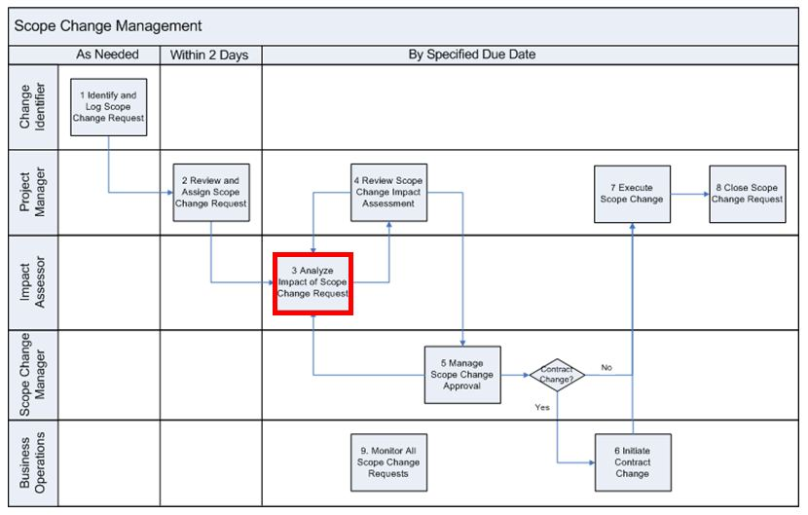

**Low Level Context Diagram**

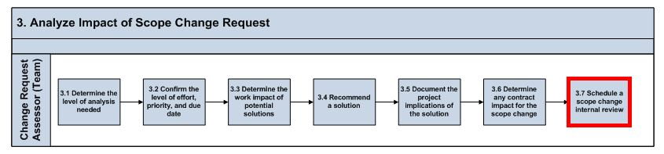

**Roles**

|  |  |  |  |
| --- | --- | --- | --- |
| **Role** | **ADM Task** | **ADM Responsibility** | **Description** |
| Project Manager | N/A | Management Oversight | Provides guidance on the Change Requests. |
| Team Lead | N/A | Primary Performer | Makes decision on what solution option will be used for each Change Request and documents that solution.  Prepares for the meeting with the Project Manager and sends a meeting request. |
| Team (All) | N/A | Primary Performer | Prepares for the final proposed solution option for each Change Request with estimate on completion. |
| Developer | N/A | Additional Performer | Helps the Team Lead prepare for the meeting with Project Manager. |

**Participant Instructions**

1. Meet with the Project Manager and discuss some of the following topics:

a. Summarizing the Change Requests for discussion.

b. Summarizing the steps taken to review each Change Request impact.

c. The idea/enhancement to address/resolve the issue.

d. Initial estimates on the enhancement.

e. What will happen if the enhancement is not implemented.

f. The team's recommendation.

2. Take notes for any feedback/updates that the Project Manager requests.

3. Update the Change Request as required by the Project Manager and resubmit the request by email.

4. Once received, read the reply email from Project Manager with the results of the Change Control Board (CCB) meeting discussing your team's Change Request recommendation.

**Hints and Tips**

* Be sure to carefully and completely document the recommendations by the Manager. The recommended changes will be expected in the Change Request you send to the Manager.
* Pay special attention to what you learned in the Productive Meetings Professional Skills training. The Manager is expecting that you apply your learning in this meeting.